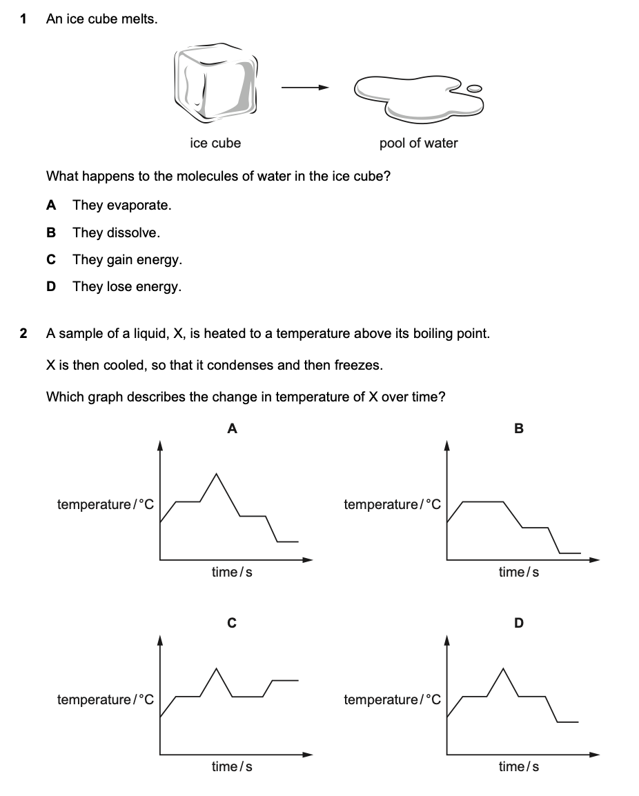
Answer: _________
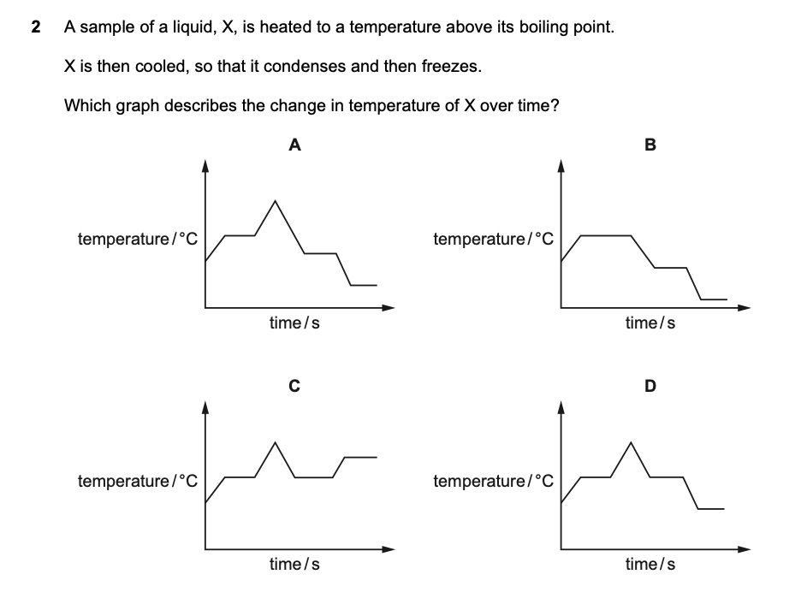
Answer: _________
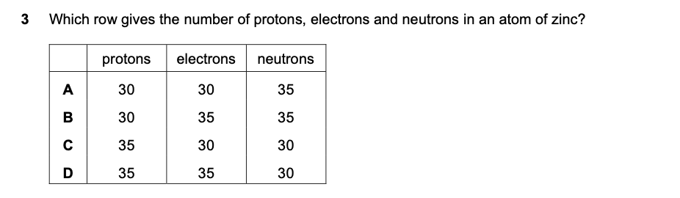
Answer: _________

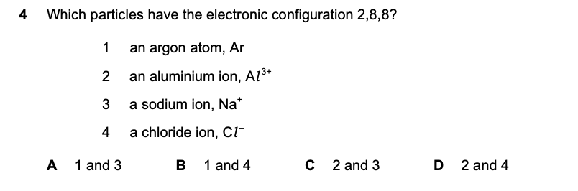
Answer: _________

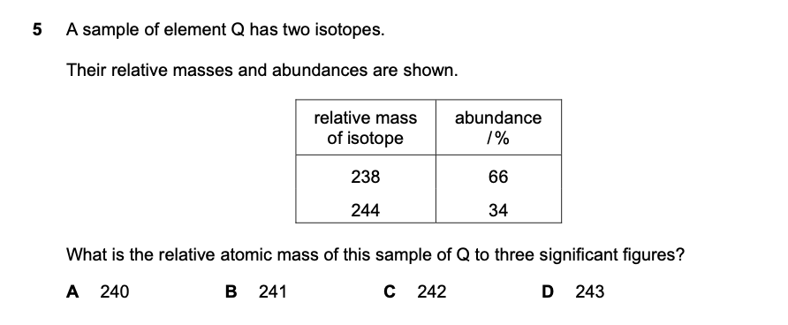
Answer: _________

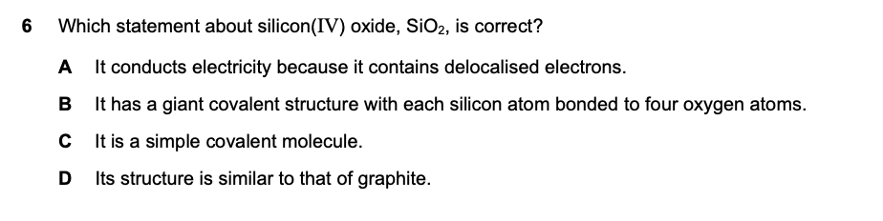
Answer: _________

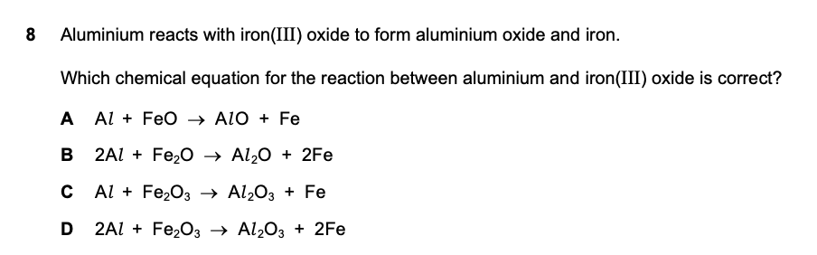
Answer: _________
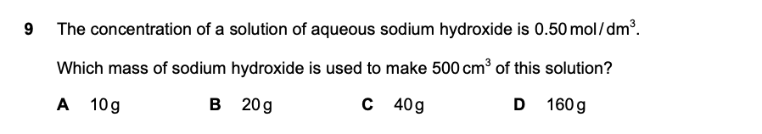
Answer: _________
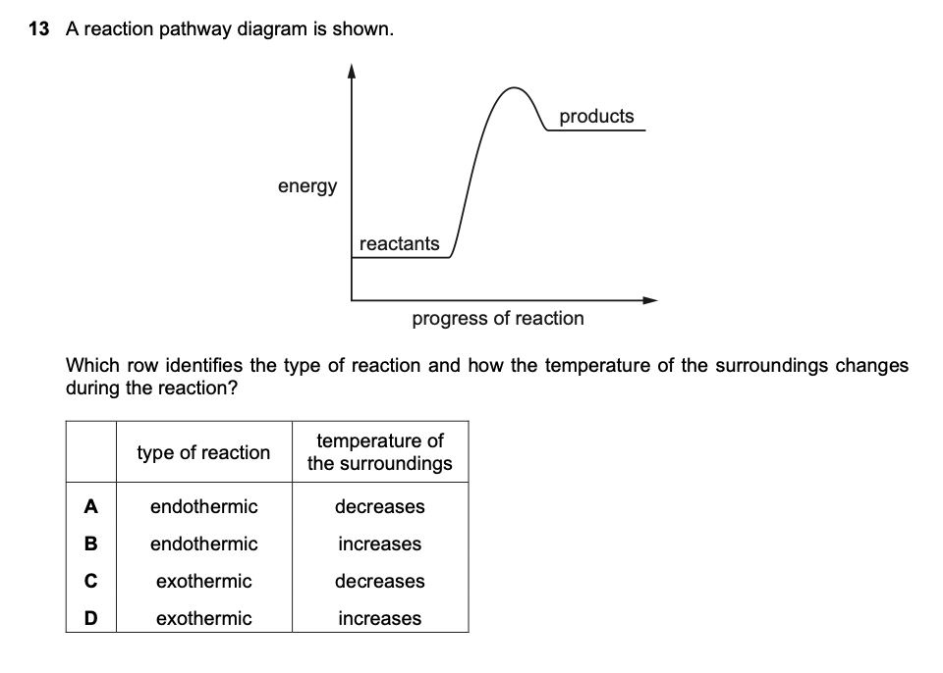
Answer: _________
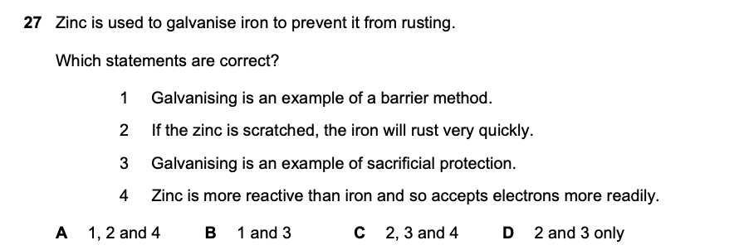
Answer: _________

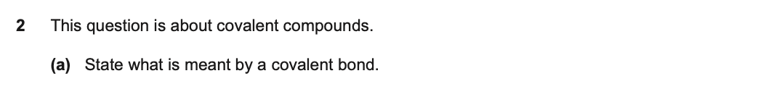
Answer: __________________________________________________________________________________________________________________________________________________
__________________________________________________________________________________________________________________________________________________
________________________________________________________________________________________________________________________________________________(2)

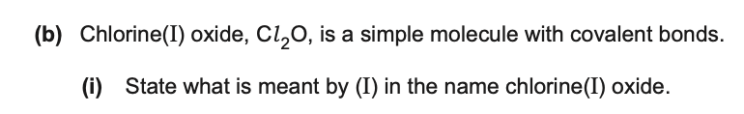
Answer: __________________________________________________________________________________________________________________________________________________
__________________________________________________________________________________________________________________________________________________
________________________________________________________________________________________________________________________________________________(2)
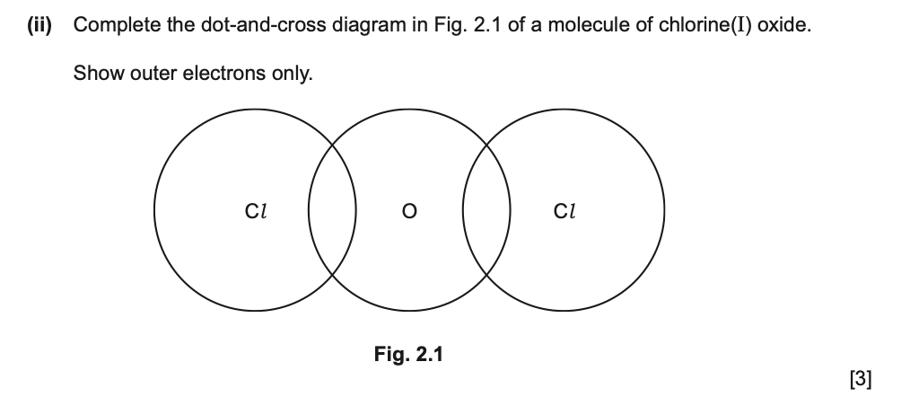
Answer: __________________________________________________________________________________________________________________________________________________

Answer: __________________________________________________________________________________________________________________________________________________
__________________________________________________________________________________________________________________________________________________
________________________________________________________________________________________________________________________________________________(3)

Answer: __________________________________________________________________________________________________________________________________________________
__________________________________________________________________________________________________________________________________________________
________________________________________________________________________________________________________________________________________________(2)
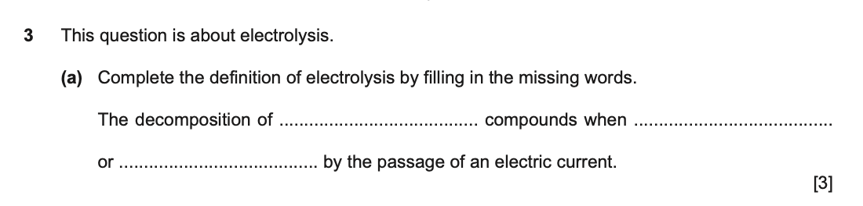
Answer: __________________________________________________________________________________________________________________________________________________
__________________________________________________________________________________________________________________________________________________
________________________________________________________________________________________________________________________________________________

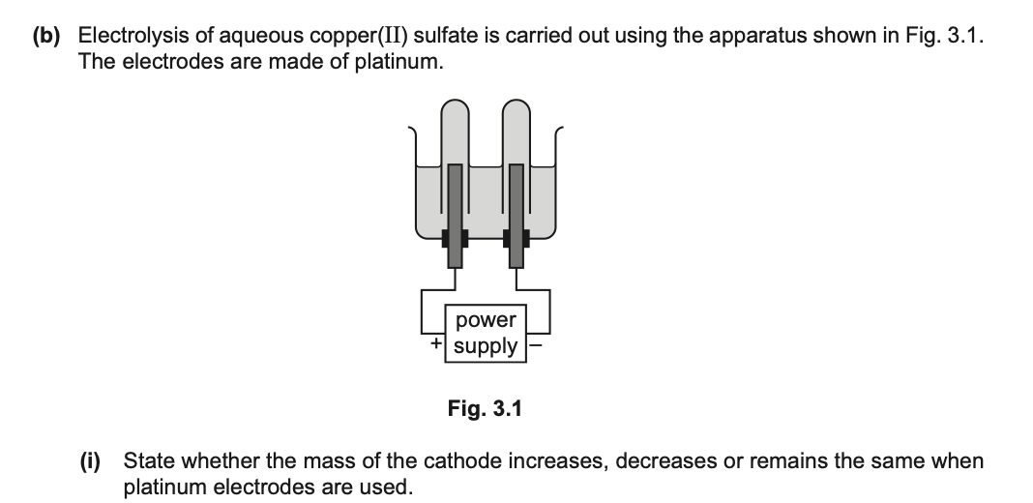
Answer: ________________________________________________________________________________________________________________________________________________(1)

Answer: ________________________________________________________________________________________________________________________________________________(1)

Answer: ________________________________________________________________________________________________________________________________________________(1)

Answer: ________________________________________________________________________________________________________________________________________________(1)

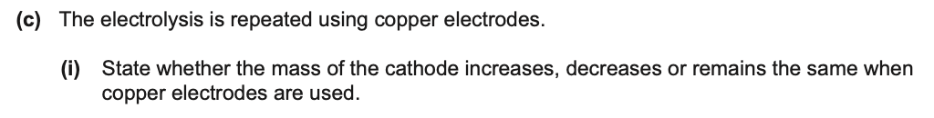
Answer: ________________________________________________________________________________________________________________________________________________(1)
Answer: ________________________________________________________________________________________________________________________________________________(1)

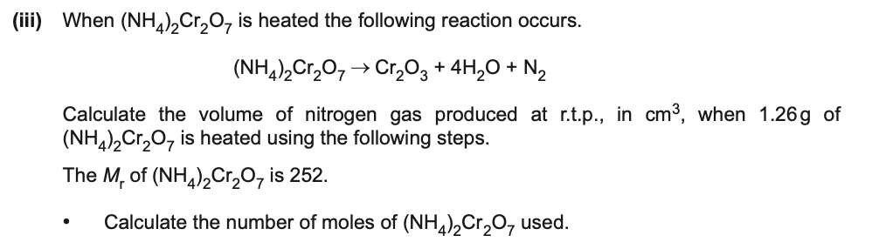

Answer: __________________________________________________________________________________________________________________________________________________
_________________________________________________________________________

__________________________________________________________________________________________________________________________________________________
_________________________________________________________________________
__________________________________________________________________________________________________________________________________________________
_______________________________________________________________________(3)

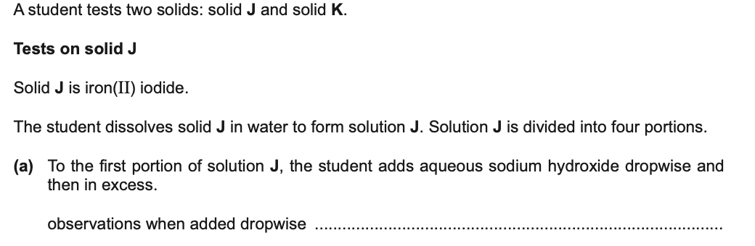Answer____________________________________________________________________________________________________________________________________________
Answer__________________________________________________________________________________________________________________________________________(2)

Observation_______________________________________________________________________________________________________________________________________(1)

Observation_______________________________________________________________________________________________________________________________________(1)

Observation_______________________________________________________________________________________________________________________________________(1)

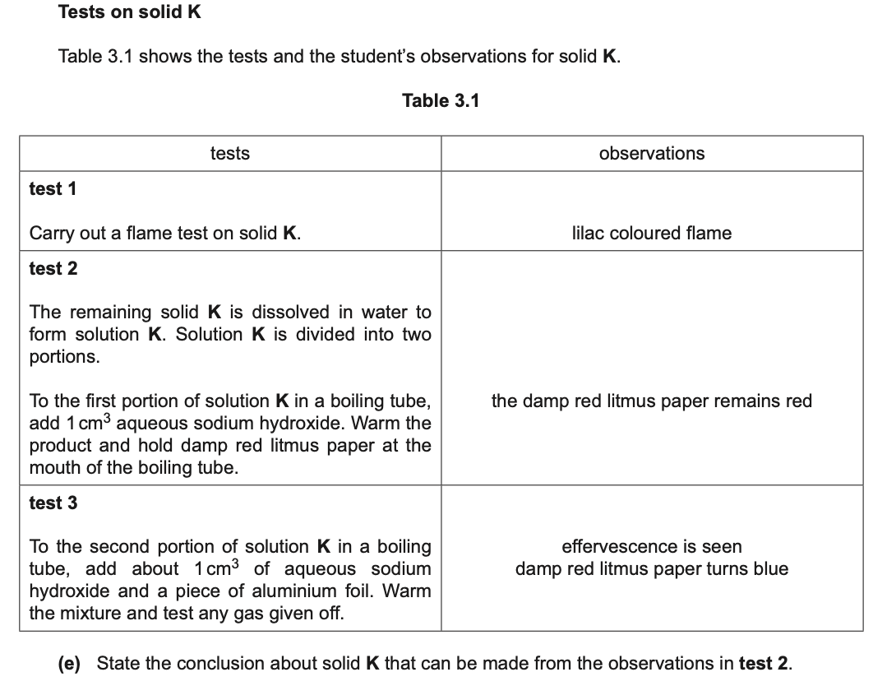
Answer_______________________________________________________________________________________________________________________________________(1)

Answer_______________________________________________________________________________________________________________________________________(1)

Answer_______________________________________________________________________________________________________________________________________(2)

